893014019

// not current implementation of Brand Count, current uses only Awk Scripting

**Brand Count**

[893014019@vclvm010312 Thu Mar 02 18:13:15 ~/893014019_WorkEnv/Workspace]$grep -v "placeholder" carList | awk '{print $1}' | sort | uniq | awk -f brandCount

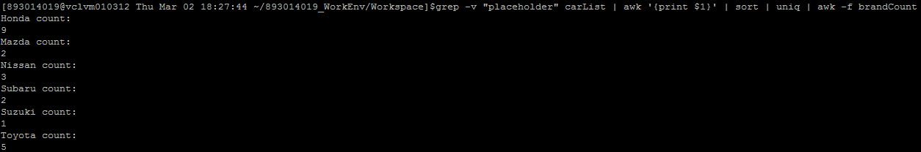

Headerfile: brandCount

{for(i=1;i<=NF;i++)\

{print $i " count: "; system("grep -vwE \"placeholder\" carList |grep -wc "$i" ")}}

**Brand Report**

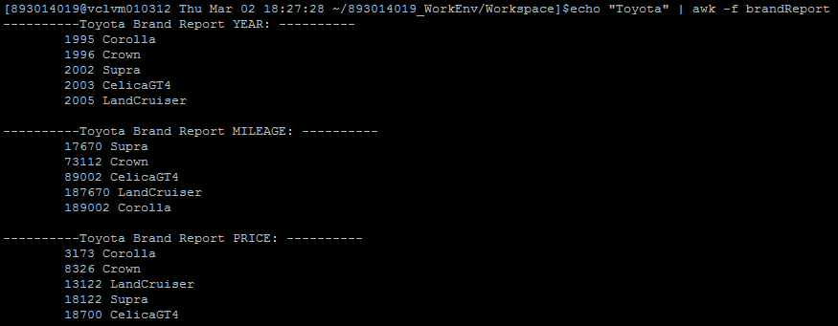

Headerfile: brandReport

{for(i=1;i<=3;i++){ \

{ printf "----------" $1 " Brand Report ";\

{if(i==1){printf "YEAR";}}{if(i==2){printf "MILEAGE";}}{if(i==3){printf "PRICE";}}{print ": ----------";}\

{system("grep -vwE \"placeholder\" carList | grep "$1" |awk '{print \"\t\" $"(i+2)", $2}'| sort -n --key=1 ");}\

{print " ";} }}}

**Cars priced $10,000-$25,000**

[893014019@vclvm010312 Thu Mar 02 18:40:54 ~/893014019_WorkEnv/Workspace]$grep -v "placeholder" carList | awk '{print $5, $1, $2, $3, $4}' | paste -s |awk -f 10_25kList

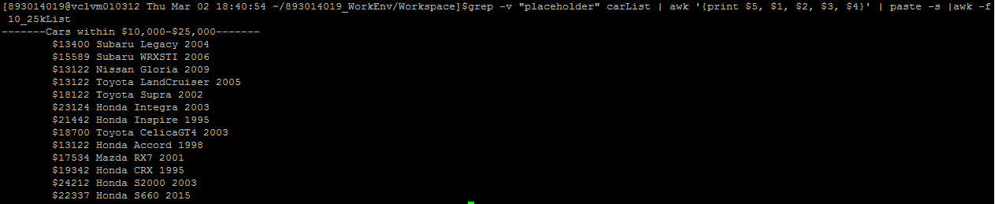

HeaderFile: 10_25kList

{print "-------Cars within $10,000-$25,000-------";}\

{for(i=1;i<=NF;i=i+5){\

{if($i<=25000 && $i>= 10000){print "\t$" $i,$(i+1),$(i+2),$(i+3);}}}}

**Most Expensive Car**

[893014019@vclvm010312 Thu Mar 02 19:00:34 ~/893014019_WorkEnv/Workspace]$grep -v "placeholder" carList | awk '{print $5, $1, $2, $3, $4}' | paste -s |awk -v n=0v=0 -f expensiveCar 

HeaderFile: expensiveCar

{print "-------Most Expensive Car-------"}

{for(i=1;i<=NF;i=i+5){\

{if($i>=n){n=$1;v=i;}}}}\

{print "\t$" $v, $(v+1), $(v+2), $(v+3);}